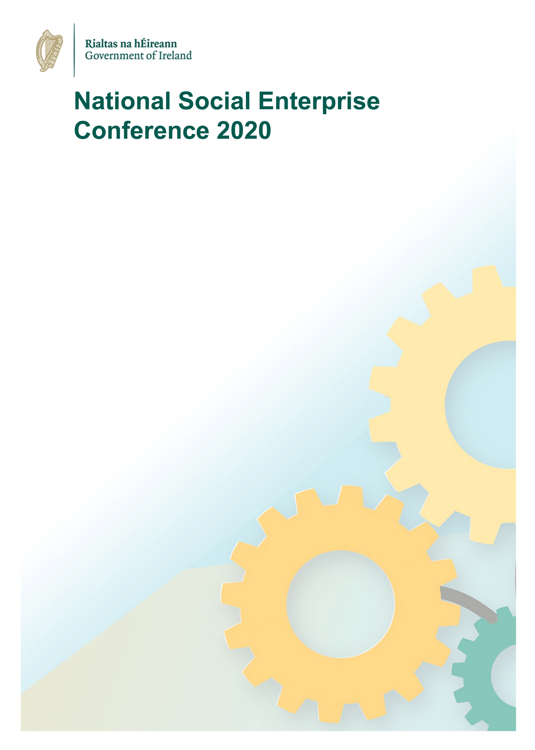

19 November 2020

Theme: ‘Shaping a Sustainable, Inclusive Recovery’

9.45am Waiting Room Opens
10.00am Welcome (Andrew Forde, Head of Rural Strategy & Social Enterprise DRCD)
10.05am Video showcase - Social Enterprise ‘We Play’
10.10am Heather Humphreys TD, Minister for Rural and Community Development
Ireland’s National Social Enterprise Policy: 1 Year On
10.20am Conversation with John Evoy, Social Entrepreneur and General Manager, ‘Grow Remote’. (William Parnell, Assistant Secretary General, DRCD)
10.45am Video showcase - Social Enterprise ‘MyMind’
10.50am Contingency
10.55am Five minute Break – (Musicantia)
11.00am OECD Perspectives on Social Enterprise, Antonella Noya, Head of Social Economy and Innovation, OECD
11.15am Launch of Social Enterprise Legal Form Guide – Sarah Farrelly, Senior Legal Manager, TrustLaw / Thompson Reuters Foundation
11.30am Round table discussion on theme ‘Shaping a Sustainable, Inclusive Recovery’ including Q&A – Chair: Andrew Forde (DRCD), Siobhán Cafferty (DoJ&E), Mary Fogarty (Loughmore Cottage, Tipperary) , and Helen Nolan (Spraoi & Sport, Donegal)
11.55am Summation – Kevin McCarthy, Secretary General of Dept Rural & Community Development
12.00pm Closing – Andrew Forde, DRCD

