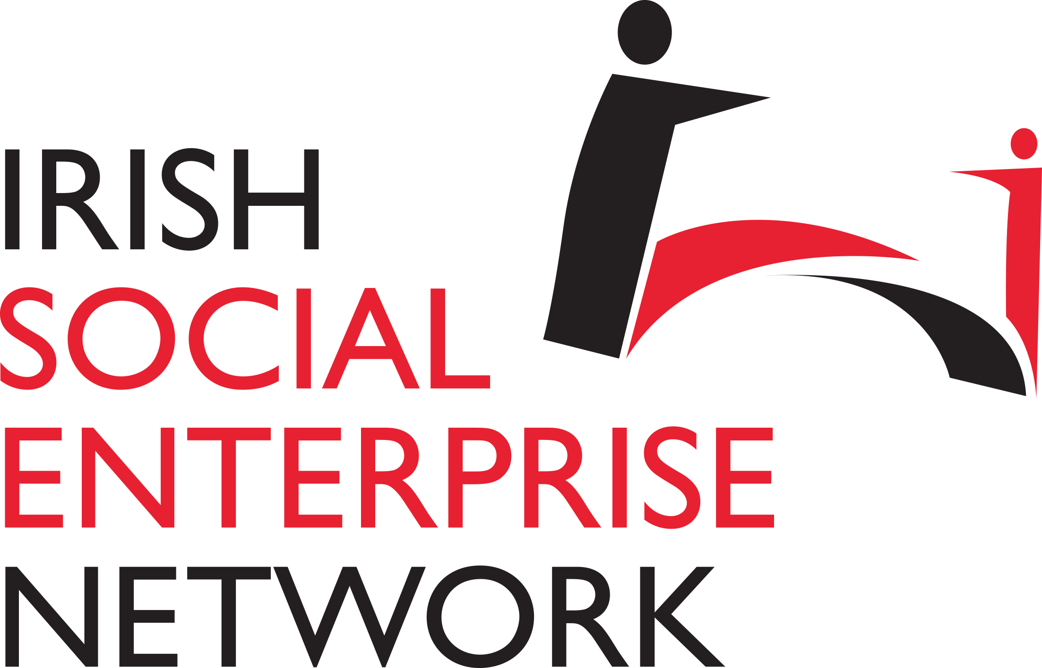
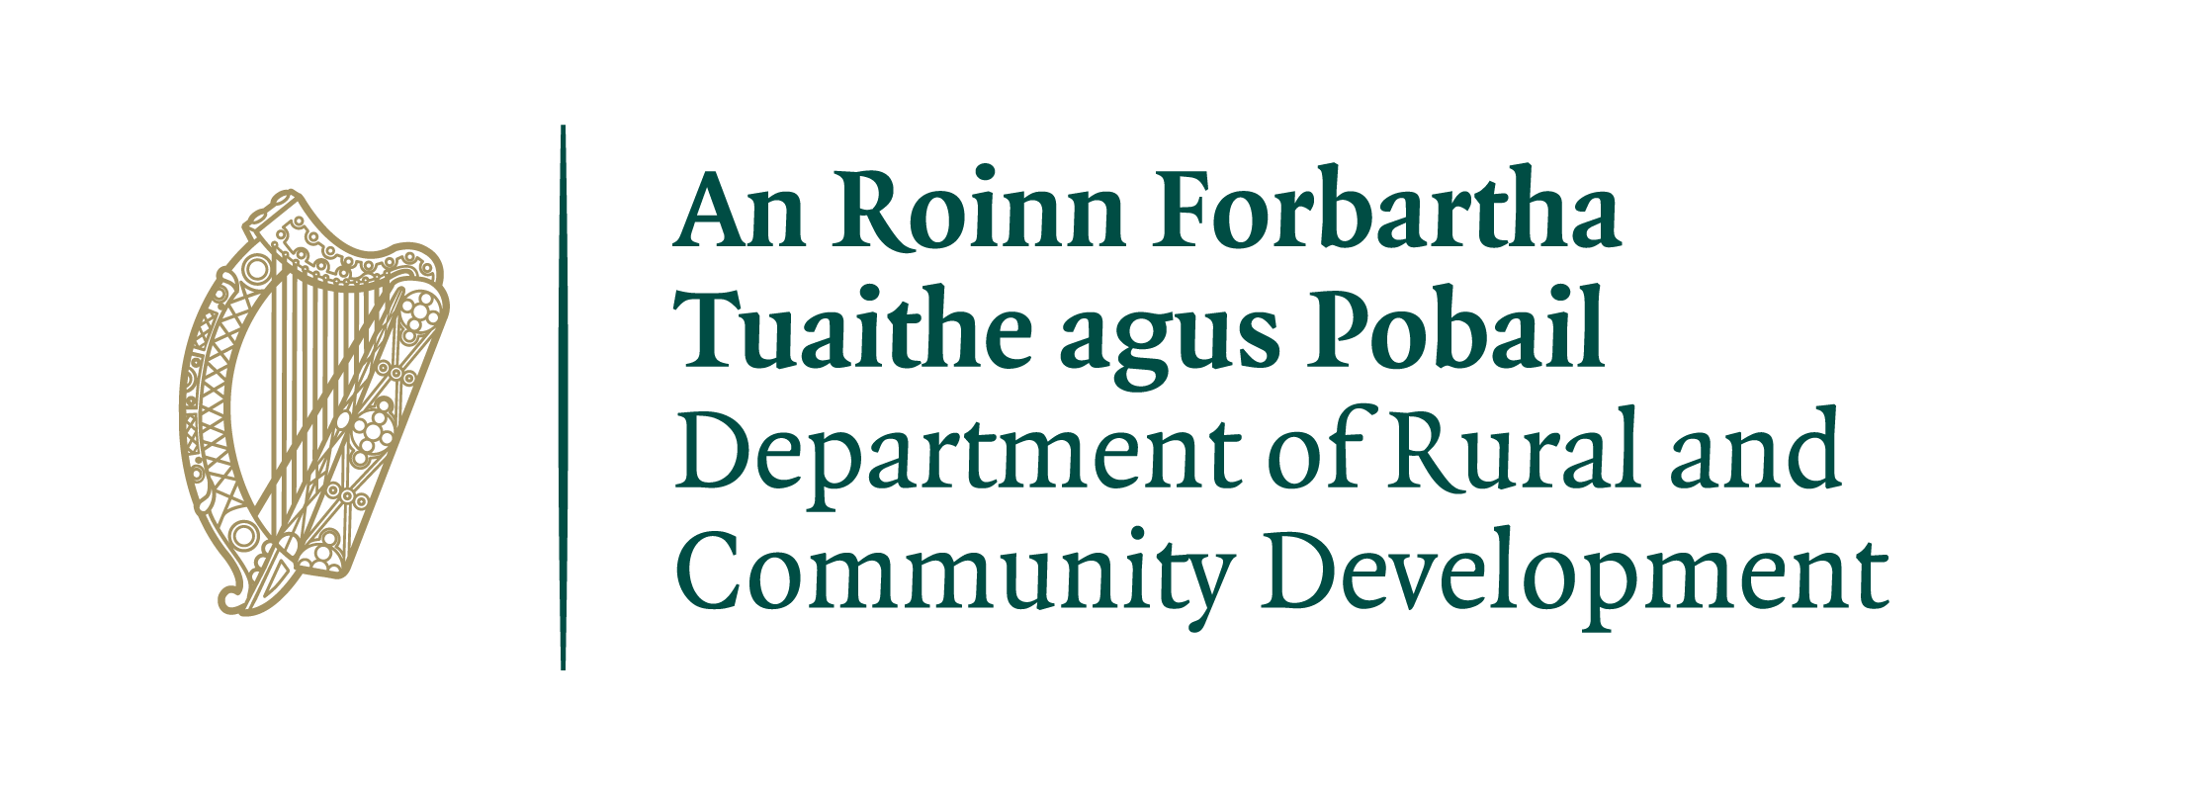

Irish Social Enterprise Network Response to National Social Enterprise Policy for Ireland 2024 - 2027 Consultation

January 2024

Introduction

The Irish Social Enterprise Network (ISEN) welcomes this opportunity to contribute to a policy for Ireland and social enterprise. We would like to see an ambitious Policy from 2024 to 2027. We believe that the consultation document could go further to match the ambition of the sector and we identify a number of core issues that can be amended or addressed to increase the impact of the policy.

ISEN would like to see ‘social enterprise by default’ becoming standard for new business development. This means encouraging new entities to consider the social enterprise model leading to better societal and environmental outcomes, supporting jobs and communities and keeping the economy supported locally and by-and-for the citizens they serve.

Social enterprise plays a meaningful role in society. This can be from employing people who are socially excluded or unemployed, through focusing on environmental or social issues that would not otherwise be addressed. Social enterprises often work with those most marginalised and hard to reach at times that are most straining including pandemics and recessions. Supporting social enterprises, supports our economy, our health and our wellbeing.

In outlining the areas where social enterprise can be effective we believe that a transformative policy can make a lasting impact.

In 2019, Thomson Reuters undertook a poll of 46 OECD countries and ranked them based on how well they supported social entrepreneurs. Ireland ranked 36 out of 43. We want Ireland to be number one.

We would like to thank our members and stakeholders for their comprehensive response to our proposal. We would particularly like to thank our European partners who we asked to contribute. These include ENSIE, DIESIS, Euclid Network, REVES Network and Social Economy Europe. We would also like to acknowledge our partners Social Enterprise Exchange Just Transition project for their unwavering support to local and regional social economy actions.

Table of Contents

Introduction 2
Table of Contents 3
1. Building Awareness of Social Enterprises 4
Definition 4
Education 4
ARISE 4
Youth Social Enterprise 5
2. Growing Social Enterprise 5
Supports 5
Enterprise Ireland 6
Local Enterprise Office Supports 6
Insurance costs 6
Upskilling Social Enterprise Supports 6
Multiannual Public Funding 7
Funding Calendars 7
European Match Funding 7
Funding forum 8
Social Enterprise Support Workers Support 8
Tax Incentive/ Rates 8
Charities Regulator 8
Procurement 9
Social Value Act 9
Cooperatives 9
3. Climate Action Contribution 10
Indigenous Energy Production & Circular Economy 10
Support European Projects 10
4. National and International Engagement 11
Local Authorities Single Point of Contact 11
Platforming Social Enterprise 11
Contribution to European Reporting & Regulations 11
Implementation of European Committee of the Regions Recommendations 12
Representative Voice 12
Long Term Planning 12
Local Social Enterprise Committees 13
5. Data Collection and Social Impact Measurement 14
Over Surveying 14
Social Franchising 14

1. Building Awareness of Social Enterprises

Definition
The definition of social enterprise could be stronger in this upcoming policy. The definition in the previous iteration is broad. This has been an advantage for many so far as the definition is not exclusionary and provided a broad base for the Department’s data collection exercise. However, this breadth risks diluting the concept and, on a practical basis, it can be difficult to assess if an organisation is or is not a social enterprise. Creating a definition of Irish social enterprise as a distinctive sector - or even a set of typologies which can be used to classify the wider Irish universe of social purpose organisations - is a difficult task and we are not suggesting that it might be done in advance of the upcoming ‘Policy’. However, it would be pertinent to include academic, practitioner and policy maker contributions to better define the term ‘social enterprise’ in future as an action of this policy. We would call on the Department to ensure that social enterprise is retained as a distinct space between nonprofit and private profit enterprise.

The Irish Social Enterprise Network is the Irish partner of the The European Network of Social Integration Enterprises (ENSIE). ENSIE wishes to highlight that it is crucial that any labels and certifications are set up with the sector in a bottom-up manner to not hamper the development of the ‘Work Integration Social Enterprise (WISE)’ and wider social economy ecosystem.

Education
Learning about social enterprise is crucial for the wider adoption of the model. Efforts should be made to include social enterprise and social economy teaching in many subjects and not just stand alone. Increasing youth engagement with social enterprise is a good ambition. Efforts should be taken to complement and draw on work around youth entrepreneurship undertaken by the European Commission and OECD through i.a. the Youth Entrepreneurship Policy Academy, moving towards a world where the entrepreneurs of tomorrow are social entrepreneurs.

ARISE
If a follow up of ARISE is to be initiated, we would ask that the Department does not specifically encourage duplication of initiatives. In previous years, many projects were due to start and finish in a short time frame and this did not allow for social enterprises to cover the cost of the work. Funding could not be spent on social enterprise themselves. Funding was only available for outside supports. Consideration must be given to the time and efforts involved in social enterprises giving of their time and effort to run this national campaign.

The ARISE funding also set all social enterprises and support organisations with a starting clock to spend monies at the same time. When the funding was released, most entities delivered 3 to 6 months with reporting completed some 9 months later. This led to many of these organisations with an influx of cash to spend, competing for the same audiences at the same time and with nothing much before and after. A more prolonged programme would even out those initiatives.

While there is often a focus on innovation and something new, it is also important to support existing initiatives. Many organisations set up campaigns that were dropped once the funding concluded. Ongoing support should be provided to core campaigns to the sector including the ‘BuySociaIRL campaign’ and BuySocial.ie website which has played such a crucial role in supporting sales for social enterprises.

Youth Social Enterprise
ENSIE fully supports the Irish government in its willingness to support youth engagement on social enterprises. The Flash Eurobarometer on Social entrepreneurship and youth states that “46% of young people aged 15-30 in the EU would consider setting up their own business, only few have taken active steps to do so. Lack of capital or resources, financial risks and insufficient knowledge and entrepreneurship skills were found as the main barriers to young people becoming entrepreneurs. In addition, only one-third of young people were familiar with the concept of social entrepreneurship.” To tackle this challenge ENSIE invites the Irish government to implement support measures to increase awareness raising on social entrepreneurship in all levels of education, facilitate access to finance for young emerging entrepreneurs in a securing and fair manner, and developing diverse forms of non-financial business development services.

2. Growing Social Enterprise

Supports

SocialEnterpriseToolkit.ie is an often downloaded resource in setting up a social enterprise in Ireland. Proposed and written by the Irish Social Enterprise Network and financed by Dublin City Local Enterprise Office, Community Finance Ireland and Dublin South City Partnership, it is now six years old and elements are dated. The resource is free at the point of use. It requires funding and finance to update a new version and expand the content. This could include additional resources to support the application and can be a central point to answer most start up questions that are often asked when commencing the journey.

Enterprise Ireland

We acknowledge that social enterprises are mentioned in the White Paper on Enterprise 2022 - 2030. We would like to see any national, regional and local economic and enterprise plans include social enterprise as a viable and desirable business model.

Local Enterprise Office Supports

Our direct experience, and that relayed to us by social enterprises and start-ups, indicate that our experiences with Local Enterprise Offices (LEOs) are mixed. We gladly work extensively with some LEOs but find that others do not engage with social enterprise as a business model. Many social enterprises report funding and supports that are available for private enterprises but unavailable for social enterprises. We support all efforts in upskilling LEOs and associated employees and consultants to be better trained in understanding the business support needs of social enterprises.

Insurance costs
Insurance costs are becoming prohibitively expensive for social enterprises - as for many other social-purpose organisations. Many social enterprises that provide jobs to those transitioning from prison or are providing waste services for example, are seeing many rising and unmanageable insurance cost rises. A cross-sector approach by Government would be welcome to mitigate costs, either by regulation or subsidy.

Upskilling Social Enterprise Supports

We note the continuing policy discussion on social enterprise legal types. We believe that one aspect that could be addressed is to improve the knowledge of existing social enterprise legal types. As the Irish Social Enterprise Network runs a national social enterprise helpline, we regularly receive requests to upskill people on how to set up a social enterprise. This can require several calls and the upskilling of individuals and advisers in legal types. We have developed a “Legal Types Workshop for Social Enterprise Support Workers” and would be available to deliver this on behalf of the Department of Rural and Community Development. We would welcome a conversation to progress this.

Multiannual Public Funding

As the baseline study showed, Irish social enterprises typically have a blended income profile. Social enterprises struggle with the delivery of existing funding outcomes with little long term security from some sources of state funding. This approach of uncertainty leads to more costly outcomes for social enterprises and funders and by extension, society at large. For example, an entity will pay a higher rental income amount for shorter term accommodation than a more long term lease on a more suitable venue due to the uncertainty of the organisation to function in a state of financial uncertainty. Giving more certainty that funding will continue also reduces anxiety and stress on staff that are insecure in their post leading to a funding cliff. We believe that the Department can bring influence to bear on other parts of government in this regard.

Funding Calendars

It is important to the sector to plan for upcoming funding applications. This work is time consuming and often done at a cost to social enterprises. The funding is often set for particular themes and offers a short window for organisations to respond appropriately. Providing a calendar of when funds might be available should be an aim for the sector and would lead to better planned outcomes instead of last minute projects that are often presented hastily. Allowing social enterprise management to plan for these funds would be transformative and encouraged.

European Match Funding

Drawing down funds from European sources is being hampered by cash flow and risk. Cash flow issues arise when certain funding streams offer monies on a staggered basis and withholding final payments. For example, a European project could provide 50% up front payment for a 24 month project, with a 20% payment halfway in and retaining the remaining 30% until after the project has completed successfully. Social enterprises and social enterprise support organisations can benefit greatly from these projects but are at significant strain in paying out this cash for prolonged periods before waiting for reimbursement.

We call upon the Department to consider a social enterprise European grant support fund to assist with no interest loans until these payments can be completed. This can significantly increase the chance of draw down, shared learnings and increased opportunities. The risk is mostly associated with the drawdown of funds and can be significantly reduced with this support.

In addition to drawdown, the planning and submission of projects requires a commitment from the government to support initiatives. Often social enterprises and social enterprise support organisations cannot entertain entering these European initiatives without some support from the government.

Funding forum

We would recommend that the department develops a funders collaboration hub to encourage funders to work more closely to support the sector instead of sometimes operating at cross purposes. This could include scheduling, details, shared knowledge forum and other methods.

Social Enterprise Support Workers Support

There is a need to consider the physical and mental health of social enterprise managers and senior staff. ISEN regularly receives calls from social enterprise workers on the stresses of the role and burnout/ physical issues. We would like to see acknowledgement of this in the sector. There are further concerns regarding pension contributions and health care.

Supporting workers in the sector is crucial for a thriving social economy and we call on supports to be made available through any agency to provide this relief.

Upskilling should also include a broader focus on green and digital skills also. ISEN are undertaking a €1m project in greening social enterprise process called ‘GreenBoost4WISEs’. Such initiatives need support in the growth and implementation.

Tax Incentive/ Rates
We believe that there is a need to give relief from tax and rates to many social enterprises across the country. Currently, there are some reliefs afforded to charitable entities and similar organisations. However, we understand that definitions are important and there are many factors that impact this conversation. We would hope that the government could commence exploring this issue.

Charities Regulator

We would welcome clarity from the Charity Regulator on the criteria for required charity registration. We work with social enterprises that are - and are not - registered charities. Some social enterprises expressly operate outside of the charitable sector. However, it is possible for third party organisations to take a view that a given social enterprise should register as a charity. As a result, it has been reported to us by many social enterprises that they have received communications from the Charities Regulator requesting that the social enterprise complies with Charity Law. We need clarity from the Regulator on these matters and the Department should take a view supporting the sector.

Procurement

BuySocial.ie has been sponsored by the Department of Rural and Community Development, Pobal and supported through European funding. BuyWISEly is a European funded project that will help WISEs increase their sales, assisting them marketing and sales and matching them with purchasers from the private and public sectors. BuySocial.ie requires significant ongoing investment and will need further support and funding to help the sector move forward. Considering the investment already placed in the BuySocial.ie initiative and its sister ‘BuySocialIRL’ initiative, we would welcome the continuing provision of financial support to provide for a continuing European ‘BuyWISEly’ project to achieve better outcomes for social enterprises in selling goods and services.

In addition, the Committee of the Regions calls for local and regional authorities to develop socially responsible public procurement processes and standards, paying sufficient attention to economic actors that present a social inclusion perspective and to environmental concerns.

Social Value Act

We encourage the development of a Social Value Act. Much like the existing social value legislation in neighbouring European countries, an Act would compel procurers to include social value outcomes in contracts.

Cooperatives

We would like to see the growth and use of the cooperative model. There are no mentions of the model in the policy and yet there is a great potential in its use. We would like to see further updates on legislation and that the Department is ready to implement the new model once it has been implemented. Preparation should be made for this event regardless of the progress of the legislation.

3. Climate Action Contribution

Indigenous Energy Production & Circular Economy

Social enterprises play a central role in meeting the nation’s climate targets. This is particularly in the areas of resource management (reduce, reuse and recycling) and the wider circular economy. There are also some proven examples in Ireland of community-owned renewable energy generation. We believe that there is scope to expand this segment of the social enterprise sector and we would welcome the Department’s influence in promoting this model of energy generation with the lead department.

Support European Projects
The Irish Social Enterprise Network is delivering in Ireland the European “Support for GreenBoost4WISEs” project encouraging decarbonisation of social enterprises. This project will offer financial support to WISEs in Ireland to reduce their carbon footprint and their energy bills. Such endeavours should be supported more widely and we would like to discuss this with the Department further.

4. National and International Engagement

Local Authorities Single Point of Contact

There are a few singular points of contact across the country for social enterprises to help navigate the complexities of local authorities. We are encouraging each local authority to develop paid roles that include responsibility for social enterprise in each community. This will allow for easier access to supports and services. This may not always be accessing monies but rather this could be a wider goal to integrate more services in local communities and local authorities. Many social enterprises report good engagement with their councils and local authorities with many more stating how frustrating and difficult this can be. The European Committee of the Regions has made a plea for the nomination of ‘national and regional ambassadors’ for the social economy to boost the sector. The committee also calls for local authorities to find means to increase the attractiveness of the recognition of the social economy, for example through widespread communication campaigns, strengthening the access of social economy players to public contracts, and through targeted financial support.

Platforming Social Enterprise

The Irish Social Enterprise Network encourages many social enterprises to seek international recognition for their work. We believe that placing Ireland on the international stage is important. We have an Irish award winner for the WISE Social Enterprise European Manager of the Year yet there was little celebration from the Department of this accolade. We need to set time to forward social enterprises to international platforms, not just awards, but social media, traditional media and other outlets. This could form part of a continuation ARISE programme.

Contribution to European Reporting & Regulations

There has been a significant increase in the number of reporting and regulations concerning ESG standards that will come into effect in the European Union including in Ireland. Ireland has an opportunity to be leaders in this field, led by the social enterprise/ social economy sectors. While there has been significant talk of sustainability and ESG in the for profit private sector and the public sector, this conversation has largely bypassed the social economy sector that has provided consistent leadership. We call on the Department to increase the visibility of the contribution of the social enterprise sector and how social impact in particular should be managed and paid for and not set solely by commercial interest parties.

Implementation of European Committee of the Regions Recommendations

The EU Committee of the Regions urges national, regional and local authorities to better tap into the potential of current rules on the specific provisions for services of general economic interest (SGEI) to make full use of the possibility to recognise social economy entities carrying out an economic activity as an SGEI where relevant; also calls for full advantage to be taken of the potential of social economy entities for developing and improving public services by involving them in managing said services;

Representative Voice

Irish Social Enterprise Network supports the proposal for a representative voice for the sector. We have been established since 2013 and have been active in representing the sector since then. We have seen many networks come and go in that time - and recognise that this is inevitable in a new and emerging sector. It is to be expected that representation will remain fluid at such a time of sectoral development . Throughout this time ISEN has remained sustainable and grows each year. We are funded through international projects through programmes and voluntary work up to 2025 with likely commitment from partners beyond that. Since 2017 we have established the BuySocial.ie website resource and continue to push for greater support from Government to allow us to support the sector. Even with our successes and our track record in securing EU funds to support Irish social enterprises, it remains the case that it is difficult to resource a representative function. We do so largely through volunteer input, our earned income and creative income generation - but find that dated models of subscription-based memberships are no longer viable or fit for purpose. A representative voice needs perhaps to be a mechanism rather than an organisation or legal structure. And the Department needs to consider how a representation function can be resourced.

Long Term Planning

During the time frame of the last policy, COVID-19 hit our communities. In that time, many social enterprises pivoted from fee making services, to being loss making ventures and crucial contact points for their communities. With the rise of communities online providing volunteer services, it was many social enterprises that bore the brunt of this impact. There may be future challenges ahead and the Government needs to be responsive to using social enterprises as critical players in the sector. Similarly, in the outbreak of the Ukraine war, social enterprises changed their initiatives to deal with the influx of new challenges such as languages, education, housing, community activities and traumas from these communities. We would like to see contingency planning and risk assessments made in the event of a similar event and social enterprises being seen as key partners and not merely as after- thoughts.

Social enterprises often step in to provide work for those that have lost their jobs in recession or other events. Regularly, social enterprises are called on to provide meaningful work for those facing stark unemployment. Given that recessions are regular medium term occurrences, it is important to consider long term planning for these eventualities and support social enterprises to develop, to be in a strong position to meet these needs as employment and societal needs change.

Local Social Enterprise Committees

The Irish Social Enterprise Network are a proud founding partner of the Dublin City Social Enterprise Sub Committee. Replicating the success of this Committee in other cities and towns across Ireland would make a difference to the active consultation and renewal of social enterprises in each county or city.

5. Data Collection and Social Impact Measurement

Over Surveying

A common refrain from the sector is the over surveying and the relentless need to fill in questionnaires and forms. This can be challenging and time consuming and is not fully thought through. Having several entities repeating the same tasks is inefficient and contributes to a declining response rate. We suggest that the baseline data collected by the Department’s contractors could be made available to academic and sectoral interests. This would enhance the relevance of studies (i.e. it would be possible to compare like with like) and that the next baseline study be timetabled and flagged well in advance to discourage conflicting studies.

Social Franchising
While initiatives such as ChangeX should be commended for their commodifying of impact, these are not replicating social enterprise franchising models. It would be of value to help the understanding, development and growth of this area considering that doing so will be at cost in the short term, but of significant value in the medium to long term.

https://eur-lex.europa.eu/legal-content/EN/TXT/HTML/?uri=CELEX:52022AR5492
https://eur-lex.europa.eu/legal-content/EN/TXT/HTML/?uri=CELEX:52022AR5492
https://eur-lex.europa.eu/legal-content/EN/TXT/HTML/?uri=CELEX:52022AR5492
https://poll2019.trust.org/country/?id=ireland

